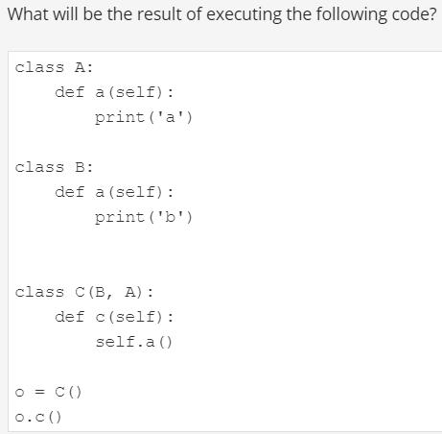

B

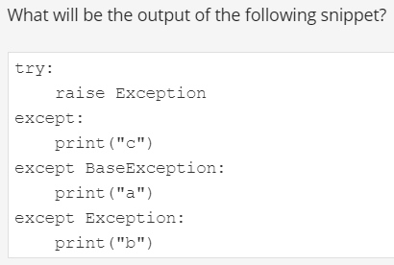

SyntaxError: default 'except:' must be last

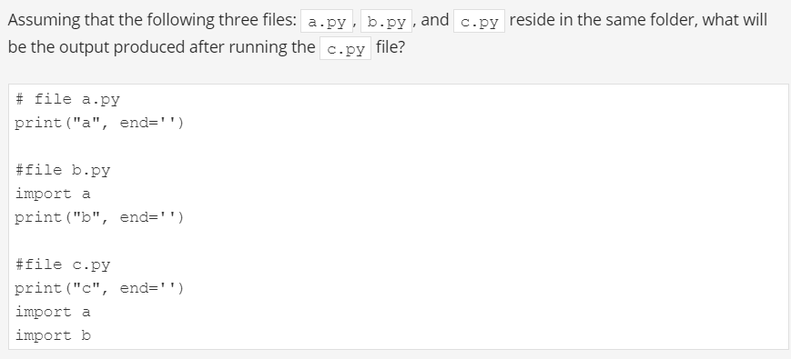

Cab

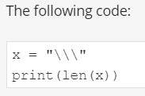

print(len('\\\'))

^

SyntaxError: EOL while scanning string literal

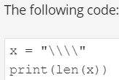

2

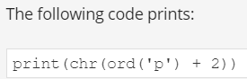

R

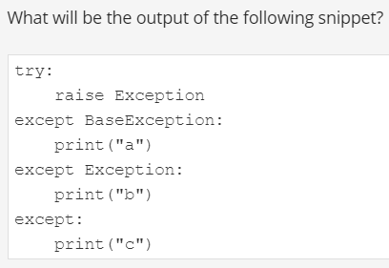

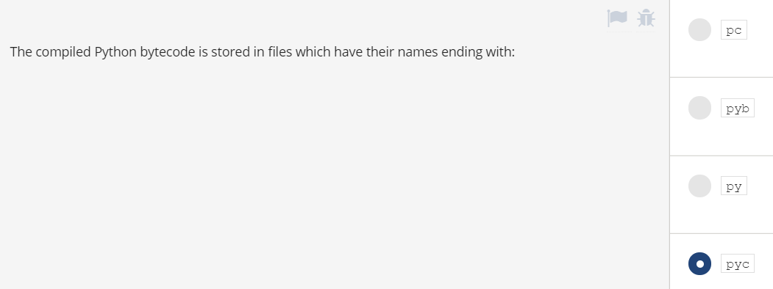

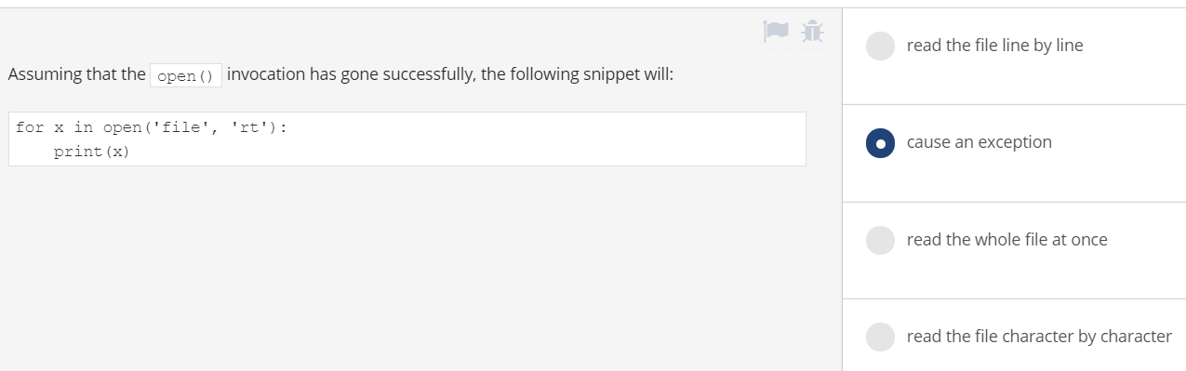

Read line by line

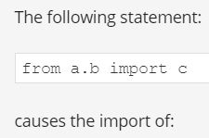

A=package, B=module()file, C=function(method)

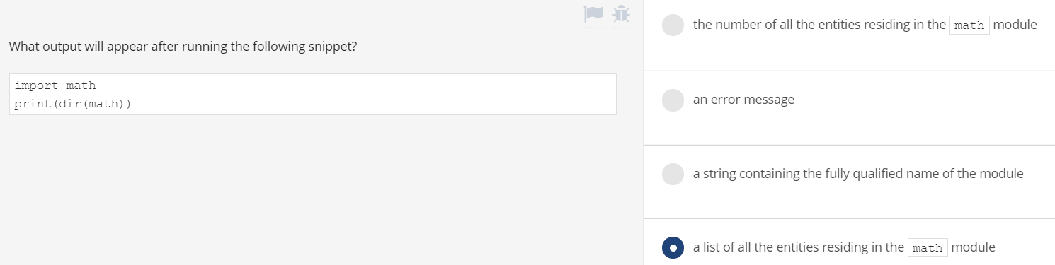

Ok,List

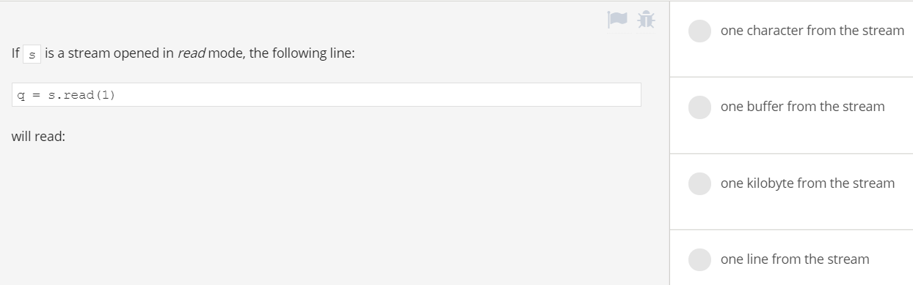

One character

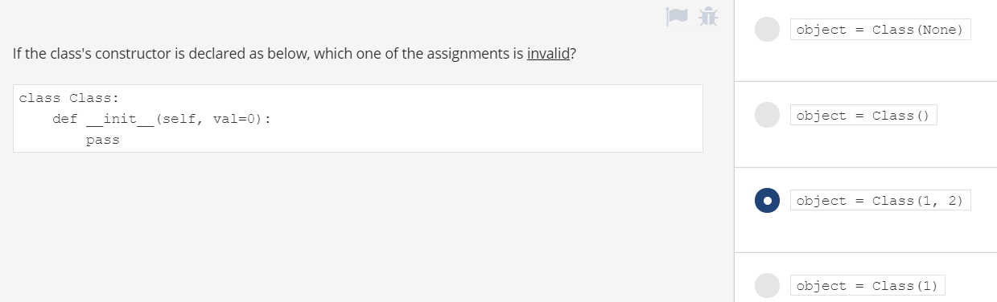

Ok

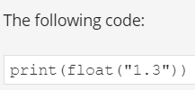

1.3

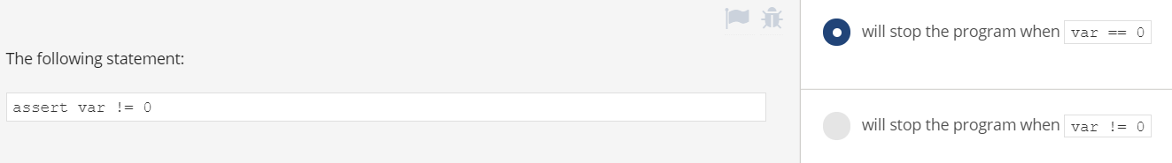

ok

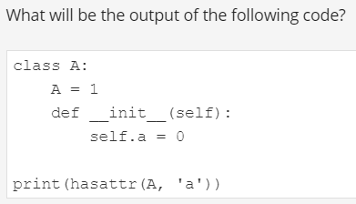

False

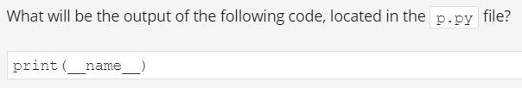

__main__

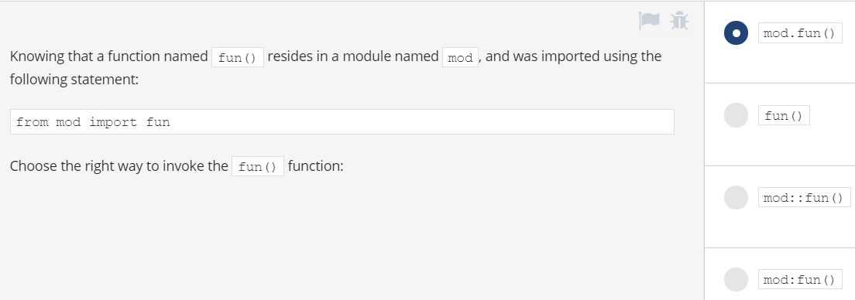

Fun()



screen

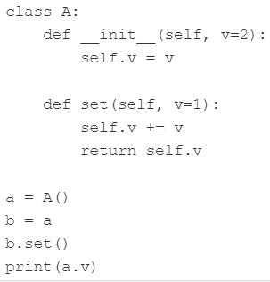

3

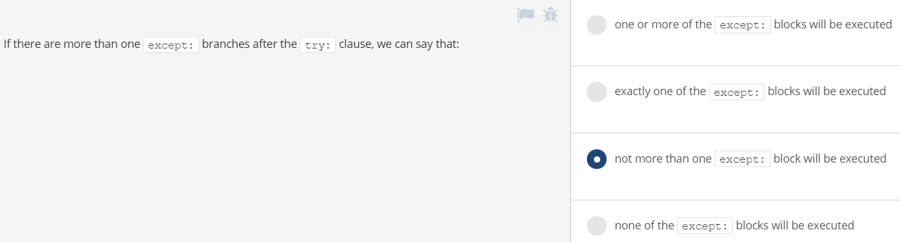

<https://www.premiumexam.net/pcap-programming-essentials-in-python/pcap-programming-essentials-in-python-quizzes-summary-test-2-answers/>